**Torsional oscillations of the Earth**

**Abstract**

It is known that when subject to large earthquakes the Earth resonates at particular frequencies. A computer model was used to calculate the natural periods of the torsional oscillations of the Earth. Taking a simple model of the Earth, where it is comprised of a homogenous liquid core and a homogeneous solid mantle, the harmonics of n = 2, 3 & 4 were found to be 43.89 mins, 28.40 mins and 21.74 mins. This falls within the range of the results found in Alterman et al. (1959) & Matumoto & Sato (1954).

**Introduction**

The Earth exhibits elastic properties, which enables the Earth to vibrate in a jelly like behaviour. These modes of vibration are excited by earthquakes and cause oscillations to occur over particular periods for each harmonic (Lapwood & Usami, 1981). Our understanding of the inner Earth is derived from seismic data. As seismic waves propagate through the Earth, the differing physical and chemical properties cause changes in the velocity of the waves. The geometry of the Earth and behaviour of seismic waves can be used to map the internal structure of the Earth. The basic idea that the Earth is comprised of a solid mantle and a liquid core comes from this.

The torsional oscillations of the Earth consist of one part rotating relative to another. The value for this displacement, U, at a given distance from the centre of the Earth, r, is given by:

$μ\left(U^{''}+\frac{2}{r}U^{'}\right)+μ^{'}\left(U^{'}-\frac{U}{r}\right)+\left(ω^{2}ρ-\frac{n\left(n+1\right)μ}{r^{2}}\right)U=0$

Where $μ$ is the rigidity, $ρ$ is the density at the given value of r, $ω$ is the frequency of oscillation and n is the order of the harmonic.

**Method**

Equation 1. was scaled in order to reduce the size of the numbers to a computable size:

$m\left(U^{''}+\frac{2}{x}U^{'}\right)+m^{'}\left(U^{'}-\frac{U}{x}\right)+\left(λσ-\frac{n\left(n+1\right)m}{x^{2}}\right)U=0$

Where $m=\frac{μ}{μ_{0}}$ where $μ_{0}$ is the rigidity at the base of the mantle, $σ=\frac{ρ}{ρ_{0}}$ where $ρ_{0}$ is the density at the base of the mantle, $x=\frac{r}{R}$ where R is the radius of the Earth and $λ=\frac{ω^{2}ρ_{0}R^{2}}{μ_{0}}$. This equation can be written as:

$$\frac{dy_{1}}{dx}=\frac{y_{1}}{x}+\frac{y_{2}}{μ}$$

$$\frac{dy_{2}}{dx}=\left(\frac{μ\left(n^{2}+n-2\right)}{r^{2}}-σ^{2}ρ_{0}\right)y_{1}-\frac{3y_{2}}{x}$$

Where $y_{1}=U$ and $y_{2}=μ\left(\frac{dU}{dx}-\frac{U}{x}\right)$. This means that the boundary condition is $y_{2}=0$ at the base of the mantle and at the surface of the Earth ( $x=0.548 \& x=1$ respectively).

In order to find a value of $λ$ that satisfied the boundary conditions $m$& $σ$ are set to 1. A value of $λ$ at $y_{2}=0$ can then be found and variable values of $m$& $σ$ can be used to find the frequency ($ω$) for selected harmonics. This can be completed for each harmonic to return a value for the period.

**Results & Discussion**

The values of $m$& $σ$ vary in accordance with rigidity, which is a function of shear velocity, and density from which these values are based. Fig.1 and Fig.2 show the Earths more

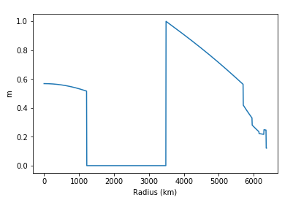

Fig.2

Shows the value of m varying with radius. 0 is the centre of the earth and 6371 km is the surface of the Earth. m is a scaled value of rigidity, which is a function of shear velocity.

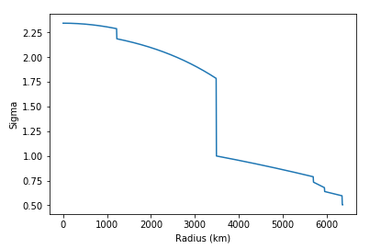

Fig.1

Shows the value of sigma ($σ$) varying with radius. 0 is the centre of the earth and 6371 km is the surface of the Earth. Sigma is a scaled value of density.

complicated structure, which varies with depth. The two-layer separation can be seen in both figures at 3485.7 km. Shear waves can’t propagate through liquid and so we see no value of m in the liquid outer core.

With varying values of $m$& $σ$ values of $λ$ at each harmonic could be found. Fig.3, 4 & 5 are the graphs for n=2, 3 & 4 respectively.

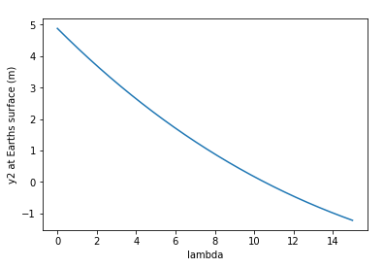

Fig.4

Shows the value of lambda at the boundary conditions for n=3, for varying values of m and sigma.

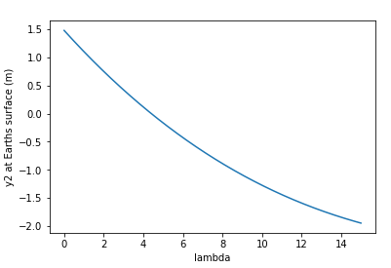

Fig.3

Shows the value of lambda at the boundary conditions for n=2, for varying values of m and sigma.

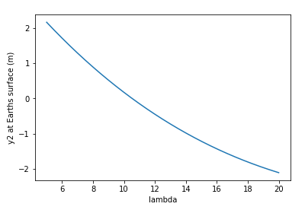

Fig.5

Shows the value of lambda at the boundary conditions for n=4, for varying values of m and sigma.

These values of lambda, both with constant m and sigma and variable m and sigma, are shown in Table.1 for each harmonic.

Table.1

|  |  |  |  |
| --- | --- | --- | --- |
| Harmonic | 2 | 3 | 4 |
| Lambda with constant m and sigma | 5.8 | 14.3 | 25.3 |
| Lambda with variable m and sigma | 4.41 | 10.52 | 17.95 |
| Period (minutes) | 43.89 | 28.40 | 21.74 |

The calculated periods of the torsional oscillation are very close to the values put forward but Alterman et al. (1959) and Matumoto and Sato (1954). Alterman et al. (1959) had values of 44.1 minutes, 28.6 minutes and 21.9 minutes for n = 2, 3 and 4. Matumoto and Sato (1954) had a value for n = 2 of 42.5 minutes.

The range of values proposed for the period of oscillation does vary (Alterman et al. 1959). This is largely due to the type of models and data sets that are used. Within the Earth, there are discontinuities in the physical properties. These impact the results and can lead to variations depending on where these discontinuities are placed. Varying information on the Earths structure leads to ambiguity about the layers within the Earth and therefore leads to varying Periods of oscillation.

The proposed model of a solid homogenous mantle and a liquid homogeneous inner core is only an approximation. As Fig.1 and 2 show the Earth’s structure is actually very complex, with little homogeneity. Trying to compute the period for a more complicated system would take a greater time, however, would yield a more accurate answer. In the future a model which considered more segments of the Earth that are of greater “similarity” could be compared with the results of previous calculations.

**Conclusion**

A computer simulation of the torsional oscillations of the earth yielded values that are in line with previous models. There are pitfalls in the model due to simplification that arise due to a lack of data and computer power. In general the model provides a good approximation of the torsional oscillation of the Earth.

**Bibliography:**

Z. Alterman, H. Jarosch and C. L. Pekeris. (1959). Oscillations of the earth. Proceedings of the Royal Society of London. Series A. Mathematical and Physical Sciences. 252, p80-95.

Lapwood & Usami (1981). Free Oscillations of the earth. Cambridge: Cambridge University Press.

T. Matumoto and Y. Sato (1954). On the vibration of an elastic globe with one layer. The vibration of the first class. Bull. Earthq. Res. Inst. 32, p247-258

**Program:**

def sigma(x):

p=0

r = x*(6371.0)

if 6371.0 > r >= 6368.0:

p+=1.030

elif r >= 6357.0:

p+=2.802

elif r >= 6352.0:

p+=2.902

elif r >= 5951.0:

p+=7.15855 - 3.85999*(x)

elif r >= 5701.0:

p+=11.11978 - 7.87054*(x)

elif r >= 3485.7:

p+=6.81430 - 1.66273*(x) - 1.18531*(x**2)

elif r >= 1217.1:

p+=12.58416 - 1.69929*(x) - 1.94128*(x**2) - 7.11215*(x**3)

elif r >= 0:

p+=13.01219 - 8.45292*(x**2)

p=p*(10**3)

p0=5.55e3

sig=p/p0

return p, sig

def m(x,p):

Vs=0

r = x*(6371.0)

if 6371.0 > r >= 6368.0:

Vs+=0

elif r >= 6357.0:

Vs+=3.55000

elif r >= 6352.0:

Vs+=3.75000

elif r >= 6291.0:

Vs+=4.65400

elif r >= 6151.0:

Vs+=4.34060

elif r >= 5951.0:

Vs+=15.09536 - 11.01544*(x)

elif r >= 5701.0:

Vs+=15.04371 - 10.69726*(x)

elif r >= 3485.7:

Vs+=9.20501 - 6.85512*(x) + 9.39892*(x**2) - 6.25575*(x**3)

elif r >= 1217.1:

Vs+=0

elif r >= 0:

Vs+=3.56454 - 3.45241*(x**2)

Vs=Vs*0.001

mu=(Vs**2)*p*1e12

mu0=2.911e11

em=mu/mu0

return em

def runkut(n,x,y,h):

"Advances the solution of diff eqn defined by derivs from x to x+h"

y0=y[:]

k1=dy(n,x,y)

for i in range(n):

y[i]=y0[i]+0.5*h*k1[i]

k2=dy(n,x+0.5*h,y)

for i in range(n):

y[i]=y0[i]+h*(0.2071067811*k1[i]+0.2928932188*k2[i])

k3=dy(n,x+0.5*h,y)

for i in range(n):

y[i]=y0[i]-h*(0.7071067811* k2[i]-1.7071067811*k3[i])

k4=dy(n,x+h,y)

for i in range(n):

a=k1[i]+0.5857864376*k2[i]+3.4142135623*k3[i]+k4[i]

y[i]=y0[i]+0.16666666667*h*a

x+=h

return(x,y)

def dy(n,x,y):

"Defines the differential eqns"

s=sigma(x)[1]

M=m(x,sigma(x)[0])

#M=s=1

node=3

y1 = y[0]

y2 = y[1]

u = [0,0]

u[0] = y1/x + y2/M

u[1] = ((M*((node**2)+node-2)/(x**2))-((s)*h))*y1 - 3*y2/x

return u

y2list=[]

for h in numpy.arange(5.0,20.0,0.001):

N=452

x=0.548; y=[1.0,0.0]

#print(h)

for j in range(0,N):

(x,y)=runkut(2,x,y,0.001)

#print(x,y[0],y[1])

#print(x,y[1])

y2list.append(y[1])

if -0.0001 < y2list[-1] < 0.0001:

print (h)

#5.8 4.406

#14.3 10.523

#25.3 17.948 with variable sigma

p0=5.55e3

mu0=2.911e11

h1=4.406

omega=((h1*mu0)/(p0*((6371*1000)**2)))**0.5

#print(omega)

period=(2*numpy.pi)/omega

#print(period)

mins=period/60

print(mins)

h2=10.523

omega=((h2*mu0)/(p0*((6371*1000)**2)))**0.5

#print(omega)

period=(2*numpy.pi)/omega

#print(period)

mins=period/60

print(mins)

h3=17.948

omega=((h3*mu0)/(p0*((6371*1000)**2)))**0.5

#print(omega)

period=(2*numpy.pi)/omega

#print(period)

mins=period/60

print(mins)